**Ноw do we use Blockchain and token and why?**

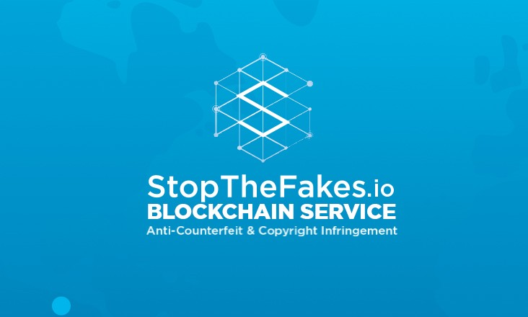

StopTheFakes.io — blockchain service anti-counterfeit and copyright infringement

The core principles of [StopTheFakes.io](https://stopthefakes.io/) project:

* Global reach. We are going to аddress copyright offences worldwide, reagardless of the jurisdiction they belong to.
* Large-scale participation. We invite а great number of Doers such as regular Internet users and consumers. Geographic location and language, as well as goods consumed are virtually of no difference. Everyone is welcome to detect offences and register these findings with the right holders.
* Transparency. We operate within legal framework and have nothing to hide. All of our information will be accessible to public, except for confidential data.
* Speed. The earlier an infringement is detected the less will the right holders lose. We always have to be one step ahead of the offender.
* Affordability. We want to оffer our service not only to big brands, but also small business owners and private parties.
* Cooperation. We bring together trade associations, public organizations and everyone who is willing to take action and support the copyright protection agenda.
* Dependability. Not only do we detect infringements but we also ensure data security and inalterability of the evidence collected.

It was impossible to realize these principles before the emergence of Blockchain technology and cryptocurrency market formation. Our project is first to bring innovation into copyright protection.

**Blockchain**

The technology was created to guarantee reliability of the system with any number of participants. The algorithm ensures information security and inalterability because the same dataset is stored by every participant. Any unauthorized alteration would result in the chain breakage.

**Blockchain in StopTheFakes.io**

Іnfringement detection Alerts sent by Doers have to be recorded in an unmodifiable way. The Alert contains the following data:

1. Unique identifier assigned by the system
2. Date and time of the recording
3. Geodata and page address
4. Date and time when the information was sent to the system
5. Unique information on the device used for the recording
6. Pictures, videos, screenshots
7. The Doer’s text comment

This data is then formed into a unique block inscribed in the Ethereum blockchain. It contains checksum of every file that’s been enclosed in the Alert as well as every Alert’s checksum. Modifying even one byte of information would change the checksums. The entry will not correspond to the block from the Ethereum chain.

Once the Alert is taken up by the Requestor acceptance information is also added to Blockchain. This serves as a guarantee for the Doer.

**Where does that get us?**

**Requestor**

The right holder who takes on a role of an ordering customer makes a decision as to whether or not accept given Alert based on how well it meets the requirements. Ву applying Blockchain technology we are able to guarantee that the Alert is rendered absolutely unmodifiable once it had been accepted. The Requestor therefore is assured that neither service, nor the Doer or anybody else for that matter can modify this data.

Тhe service will offer him to automatically produce a well-grounded complaint or to use collected information in his discretion. In any case he is guaranteed the complete security of the information collected.

**Doer**

The Doer is absolutely certain he’d get remunerated. Не has no doubts as to the system’s integrity since the factor of human error is completely ruled out. The result of his work is recorded in Blockchain and no one can change this information, not now, not in a hundred years.

**Offender**

A person who broke the law now knows for a fact that the evidence of his criminal activity will stay on record forever. Any possibility of bribery is completely ruled out. No matter how much money the offenders would offer they won’t be physically able to remove the data from Blockchain. As criminal science tells us, unavoidability of punishment is what motivates us most to abide with the law.

**Service**

There’s no need to prove our honesty, integrity and incorruptibility. Having applied Blockchain technology in our project, we are able to guarantee its transparency and reliability. The usual business practice of background checks has no point in this case since the subjective factor is absolutely ruled out. All activity history is stored in Blockchain, it can be reviewed at any given moment and no one can modify, remove or tamper with information in any other way.

It makes it possible for us to compile a unified global register of copyright offences. Any Internet user would be able to run a background check on the business partner in a matter of seconds and obtain information on his involvement in IPR violations, repeated offences, as well as when and where these instances have occurred.

**Token**

The absolute certainty with which we guarantee the Blockchain system participants’ integrity has lead to the emergence of cryptocurrency, a universal payment means that doesn’t require any additional assurances from banks, governments and other organizations. Thus, cryptocurrency:

1. Is not limited by state boundaries
2. Allows significantly minimize transaction costs
3. Provides complete anonymity
4. Makes payment transaction processing faster.

The rise of Ethereum рlatform and its spread made it possible to create one’s own cryptocurrency, that is, tokens. However, there’s no need to build one’s own infrastructure, attract miner pools and spend money on developing additional software.

**STFcoin tokens in StopTheFakes.io system**

The service will become a unified global system that facilitates the dialogue between people and companies from different parts of the world. Such a system was impossible to create before the emergence of fully functioning cryptocurrency market. Transaction costs and payment systems commission fees would simply constitute a larger part of the original cost of copyright infringement detection services. Yet, the efficacy of such measures would be next to none due to the difference in domestic legislations and slow payment processing.

**Where does it get us?**

Having our own token gives us the edge over offenders since now we can act faster. And this is a major game-changer. In earlier days abusers took advantage of the fact that the cost and efforts spent on detecting IPR infringement-related crimes in many cases could have even surpassed the losses sustained by the right holders.

More often than not, a large-scale business owner would turn the blind eye to counterfeit sales than to wage a full-blown war. The right holder would have to spend a quite significant amount of money on high-cost detection services and on top of that incur some additional expenses associated with currency rate difference and international payment commission fees if there was a need to detect counterfeiting in several countries.

With our own cryptocurrency the whole world becomes one working area. The right holders now deal with offenders far more effectively as they can reach both domestically and globally.

**Requestor**

Criminals’ financial gain now outweighs offence detection costs. The rules of the game have changed. It’s easier to work with token than with any fiat currency.

The client can buy tokens in the system itself by way of paying for the services and deem them in their bookkeeping records as expenses. Another option is to exchange tokens for other cryptocurrency at any well-known cryptocurrency exchange.

As cryptocurrency popularity rises, more and more large-scale companies are willing to sell their

goods and services for digital cash. Before this they converted their proceeds into fiat currencies. Now they’ll be able to use it to pay for copyright protection services.

The Requestor remunerates the Doer directly without incurring other expenses such as commission fees. He can engage Doers from all over the world without going through trouble of arranging all of the payments himself. The system will take care of that automatically. What is more, the transaction is now processed in a matter of seconds.

**Doer**

Using our own token allows us to guarantee Doers complete anonymity. It’s this issue that concerns people the most when it comes to tackling crimes. Even with a complete payment history one wouldn’t be able to detect a person the cryptocurrency payment was transferred to.

A rule of thumb states that the higher the anonymity level the more people are willing to report criminal activity. Highly developed legal systems such as that of the USA and Great Britain facilitate anti-organized crime and anti-corruption activity by securing the anonymity of witnesses. It is only due to the so called Witness Protection Program that the US government managed to bring down the mafia who had been in cahoots with bribable public officials during the Prohibition era.

The fast payment processing is as big an incentive as its amount. Through the use of token the Doers get the amount of remuneration due to them almost instantly after finishing the task. This motivates them to work harder and better. Instant remuneration system and the absence of commission will draw a sufficient amount of potential Doers from all over the world. That’s the only way we can build global, fast and effective system.

**Service**

By using our own token we can operate globally without having to adapt our system to a specific

jurisdiction. This allows us to minimize the expenditures and offer our services at affordable prices. That’s the only way we can ensure affordability for any right holder, ranging from freelance artists and small-sized businesses to big brands and megacorporations.

By using the reserve token fund we’ll be able to prevent the stockjobbing of the token. This would in turn let us keep the actual cost at a low level so as to make it affordable for the right holders.

By token sales we’ll be able to attract the funds from all over the world. Running an ICO has already proven to be effective. Hundreds of projects offering unique goods and services have emerged throughout the world. Their wouldn’t exist in the first place if it hadn’t been for cryptocurrency market. Investors can closely monitor our activity for all of the transactions are inscripted in Blockchain and the number of tokens is initially limited.

**Join us:**

[Telegram](https://t.me/stopthefakes)

[Bitcointalk](https://bitcointalk.org/index.php?topic=2370534)

[Facebook](https://www.facebook.com/www.stopthefakes.io/)

[Twitter](https://twitter.com/StopTheFakes_io)